Git Hub Repository Link:

<https://github.com/ST10375898/POE-PART-3>

**User Manual**

**Welcome to The Recipe Recorder App User Manual**

This user manual consists of all the necessary information that is needed to run the Recipe Recorder Application. Included with the instructions of usage are screenshots of the application in its functional state to let the user know exactly what to do.

**Section 1**

This section focuses on how to get the project from GitHub in order to run the application on Visual Studios.

1. Open the following repository by using this link (<https://github.com/ST10375898/POE-PART-3> ).
2. You can get the application on your personal computer through the following methods once you are on the repository:
   1. Cloning the repository directly to Visual Studios
   2. Downloading the zip file of the project that is available on the application.

* Unzip the zip folder and ensure that the file is fully extracted.
* Open the solution on Visual Studios 2022.

1. Once the application is on Visual Studios you can go ahead to run the application and you will see the main window of the application which looks like the below screenshot:

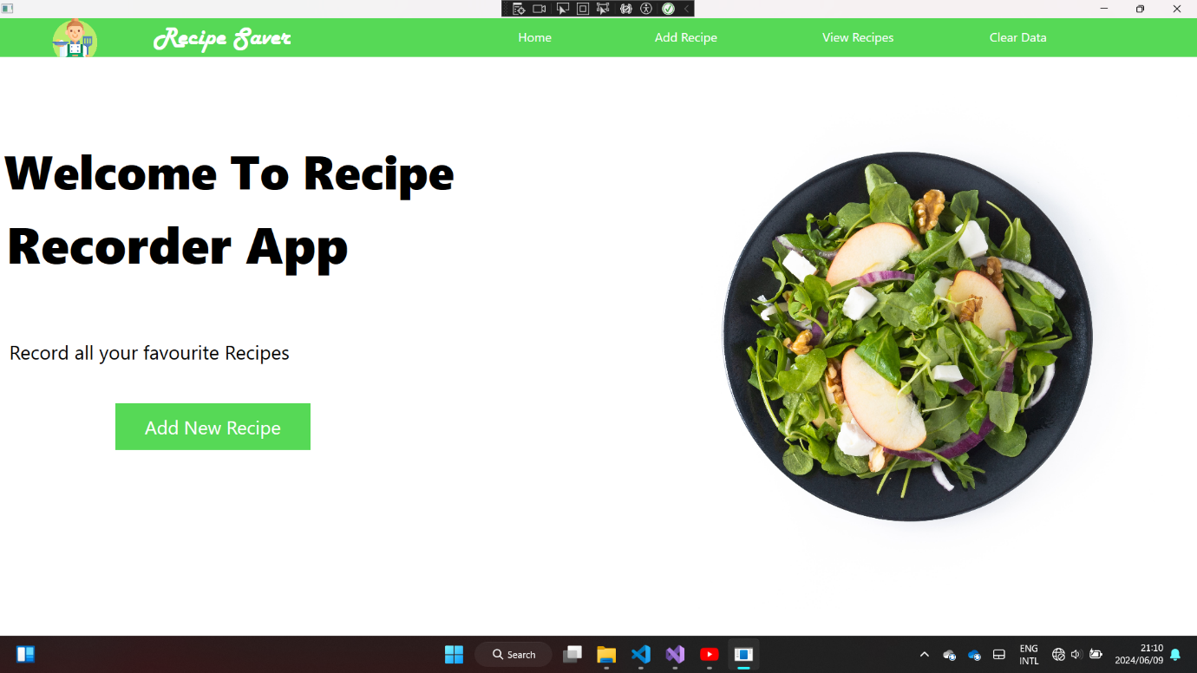

1. Now you can go on to select the options that are available on the home screen. These options include the following:
   1. Home: Which displays the home screen
   2. Add Recipe: This shows the screen that has controls that allow a user to enter the details of a recipe.
   3. View Recipe: This shows a screen that has controls that allow the user to view the recipes that are available and their details.
   4. Clear: This buttons simply deletes all the recipes that are on the system.

**Section 2**

In this section we will go through how each of the screens of the applications work when a user is entering the details of a recipe.

**Add Recipe Screen**

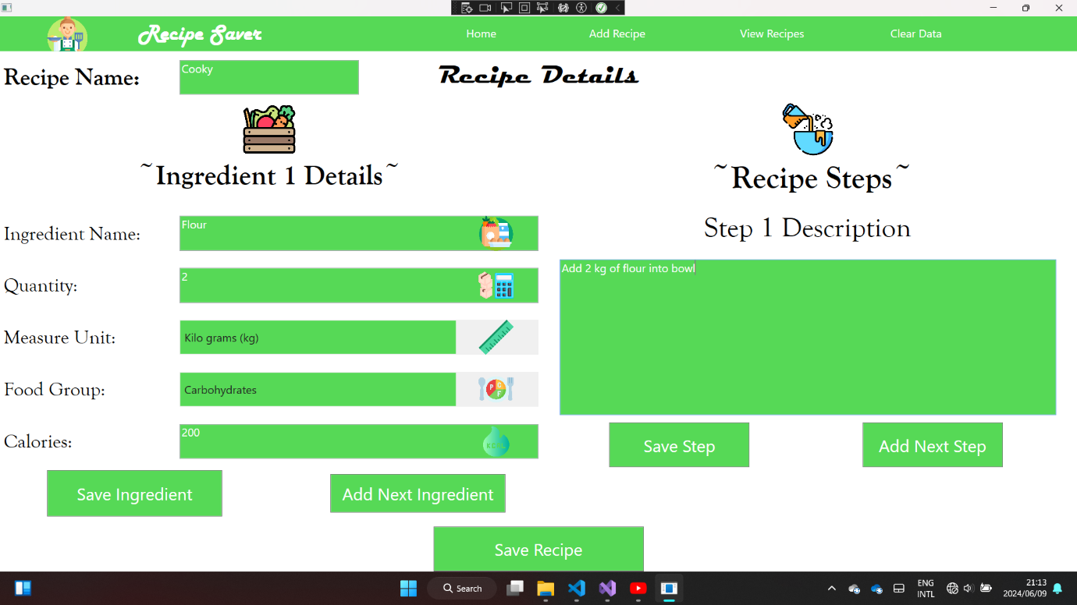

When a user is entering the details of a recipe these are the steps that the user must follow:

1. The user must start by entering the name of the recipe.
2. Then they move on to enter the details of the first ingredient. These details are as follows:
3. Recipe Name
4. Quantity
5. Unit of Measure
6. Food Group
7. Calories
8. Once all these details are entered for an ingredient the user must now click the save ingredient button that will save the ingredient details.
9. The user can then press the Add next Ingredient button to enter the next ingredient after all the ingredient detail fields have been cleared.
10. Now the user can move on to enter each description of each step of the recipe.
11. The user now must press “Save Step” button to save the step that they have entered.
12. Once the user is done entering all the details of the recipe, they can click the “Save Recipe” button that will allow the user to save the recipe with all its details.

Errors to Avoid:

1. When user enters a string or character input on the Quantity and Calory fields the user will be informed that the system only requires numbers for these fields.

**View Recipe Screen**

Once all the details of a recipe have been entered the user can press the view recipe button that will make the following screen to appear:

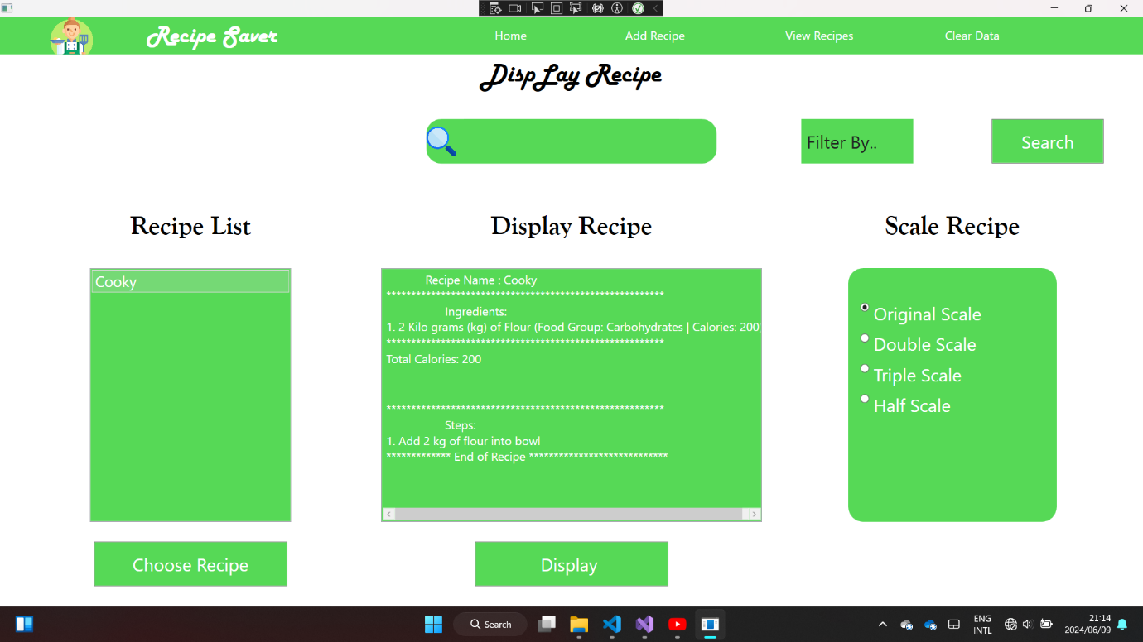

If the user wants to view a recipe they must perform the following steps:

1. The user must click the “Choose Recipe” button that will make all the available recipes to appear in an alphabetical list format.
2. The user must now select a recipe that would like to display and then click the “Display” button, which will show the details of the recipe (ingredients, steps, and total calory count).

If the user wants to scale the recipe they must follow the following steps:

1. They must click on a radio button with the scale that they want use to show the recipe. Clicking the radio button will automatically change the output to scale.

If the user wants to filter the recipe by and ingredient name, food group or a calory count then they must follow these steps:

1. The user must enter the search term that they want to use to find their desired recipe.
2. They must then choose the filter that they want to use to find their desired recipe.
3. Then they must click the search button that will filter the list of available recipes by the appropriate search criteria.
4. If the search item is not found, then the system will inform the user that the search query that they are looking for cannot be found.

**The Clear Function**

When the clear button is clicked the system will simply wipe all the information of every recipe that is on the system upon the pressing of the button. After pressing the button the system will alert the user with a dialog box that all recipes have been deleted and will then take the user to the Add Recipe screen prompting the user to enter new recipes.